**CRRT Clinical Pearls**

**RRT Nurses are the specifically trained group to set-up CRRT when changing sets**

**MODES** –

* **CVVHDF** – Continuous Veno Venous HemoDiaFiltration:
* Default & most common
* Closest function to native kidney
* Solute clearance by diffusion & convection
* Uses Dialysate & Replacement fluid
* **CVVH** – CVVHemofiltration
* Solute clearance by Convection
* Uses replacement fluids
* **CVVHD** – CVVHemoDialysis
* Solute clearance by Diffusion
* Uses Dialysate
* **SCUF** – Slow Continuous UltraFiltration: Fluid removal only.
* **SLED** - Sustained low efficiency daily dialysis.

**MOVEMENT TYPES**

* Ultrafiltration – Movement of FLUID through a semi-permeable membrane. ‘Fluid management’
* Diffusion – Movement of SOLUTES (molecules) from higher to lower concentration. Dialysate used to create a concentration gradient
* Convection – Movement of SOLUTES with water flow, ‘solvent drag’. Driven by Replacement Fluids.

**FILTER OPTIONS:**

* M150 – Most common set utilized.
* M100 – Available if ordered.
* Oxiris – Used for COVID-19 patients because the fibers are heparinized.

**PRESSURE PODS** - Areas of monitored pressure within the CRRT set, located at 4 sites:

* Access Pressure – amount of pressure required to pull blood *from the patient* via the **RED** Access Line
* Typically negative (-50 to -150)
* Return Pressure – Amount of pressure required to return blood *to the patient* via the **BLUE** Return Line
* Usually positive (50 to 150)
* Filter Pressure – Amount of pressure required to push blood into the hemofilter
* Usually positive (100-250)
* Effluent Pressure – Amount of pressure required to deposit ultrafiltrate into the dialysate bag
* Can be positive or negative, depending on flow rates and filter efficiency
* Can be -150 to 50

**SCALES**

* Post-Replacement Line/Scale – **PURPLE**
* Dialysate Line/Scale – **GREEN**
* Pre-Blood Pump (PBP) Line/Scale – **WHITE** (Delivers replacement fluid before PBP)
* Effluent Line/Scale – **YELLOW**

**PARAMETERS**

* Transmembrane Pressure (TMP) – pressure difference between the solution and the blood compartments in the filter.
* Will trend increasing pressures from clogging (particulates of infection, etc)
* Pressure Drop – Pressure change between blood entering and leaving the hollow fibers of the hemofilter.
* Trends increasing pressures from clotting (blood coagulation)
* Filter Clogging: When TMP goes up while the pressure drop stays stationary.
* Filter Clotting: When pressure drop and TMP go up together.

**DETECTORS**

* Blood Leak Detector (BLD) – Uses light transmission to detect blood in effluent from a broken hollow fiber. Can be falsely triggered by liver failure or rhabdomyolysis when myoglobin or bilirubin affect the light transmission.
* Deaeration Chamber – Monitors for air formation caused from turbulence from high flow rates of blood or fluid.
* Monitor level hourly and adjust level prn.

**ALARMS**

* **RED** alarm - A patient hazard exists. All pumps are STOPPED.
* Warning / Malfunction Alarms – Ex: air bubbles detected or return clamp failure
* **YELLOW** alarm
* Caution - Blood & Anticoag pumps continue, but treatment stops. Ex: Bag empty or Effluent Bag full
* Advisory - FYI / all pumps will continue. Ex: Preventative maintenance is due.

**INTERVENTIONS**

* End Treatment - To terminate treatment, unloads set, puts machine into END mode.
  + Only use when treatment is fully being discontinued for patient. This will wipe out the patient history.
* Change Set - To change set and resume.
* Used when filter is expiring or clotting/clogging.
* Advisory occurs after 72 hours or 780 L is processed
* Return Blood – Returns blood volume in circuit. Volume varies based on filter size (~152-187 mls in set)
* Press & Hold to return

**LABWORK**

* Renal Panel q6h (default)
* Mg q6h (default)
* iCa (from pt art line), SiCa (from system @ post-filter port)
* iCa goal is 1.1 - 1.3 *when on Calcium infusion*
* SiCa goal is 0.4 - 0.5 *when on ACD-A infusion*
* PTT (from post dialyzer port) *when on Heparin gtt*
* Goal PTT 50-80
* Discontinue ICU electrolyte replacement protocol, refer to CRRT electrolyte replacement parameters on MAR under Continuous. Read admin instructions carefully.
  + Magnesium < 1.5-1.7
  + Potassium < 3.2-3.5
  + Phosphorous < 2.5
* Possibly Lactic Acid, ABGs ~q6h
* Calcium Ratio (Citrate Gap) – Perform every 6 hrs or as ordered (when on ACDA)
* (Serum) Corrected Ca x 0.25 / Pt iCa (ionized calcium)
  + Documented on CRRT flowsheet
* If Gap >/= 2.2, **hold** ACD-A & CaCl for 6 hrs & resume gtts at 70% once gap <2.2

**ANTICOAGULATION** (stop if CRRT stopped) – no initial lab draw unless ordered

* ACD-A (Anticoagulant citrate dextrose-A): acts as an extracorporeal *anticoagulant* by binding the free calcium in the blood (calcium is a necessary co-factor to several steps in the clotting cascade).
* 0-240 ml/hr, start @ 120 ml/hr, titrate based on SiCa levels **If set goes down/stopped, stop both ACDA and
* Calcium Chloride 4g/500ml NS CaCl. RESTART at previous rate.
* Start @ 48 ml/hr (40% of ACD-A), titrate based on iCa scale
* Heparin (Syringe vs Gtt)
* Continuous Infusion via 20 ml Baxter/BD syringe
* Advisory-Syringe Almost Empty : 5 mins until empty
* Bolus prn
* None
* Flush system/filter set with 100 ml 0.9% NS every 1-2hrs **as needed** to monitor filter clarity.
* If this method is used, volume needs to be added to hourly intake.

**CONSIDERATIONS**

* Electrolyte replacements – per MAR.
* Blood Warmer / Bair Hugger – Remember that clotting is dependent on normothermia.
* Septic patient with elevated lactic – clogging filter expected.
* Ordered UF (aka: prescribed fluid removal)
* Net 0 = Intake minus output with no extra removed
  + ex: Patient is not getting anything extra in or out.
* Net Negative = Intake minus output + removing additional fluid
  + ex: Everything going into the patient is being removed+ whatever the set prescribed fluid removal.
* Net Positive = Not everything is being removed.
  + ex: Patient is keeping everything (+ fluid balance)
* Order Ex: Ordered UF of 100, unless on pressors then 0-50

1 unit PRBC ordered

High intake x 1hr – spreading out over 2 hours

* Entering Weight and Hct at 0600
* Dialyzing off meds
* Planned rinse back to travel
* If machine has been down for a period of time, start fluid removal at 0 mL/hr for approximately 15 min or as patient tolerates.
* If patient is not tolerating a blood flow rate, must notify nephrologist for any changes.

**HOURLY MONITORING**

* Strict Intake / Output (ALL inclusive: TF flush, FMS, etc) Intake – Output = Fluid Balance +
* Machine Pressures – 4 pod pressures
* Flow Rates – Blood, Replacement Fluid, Dialysate, Effluent

**Standard CRRT Orders**

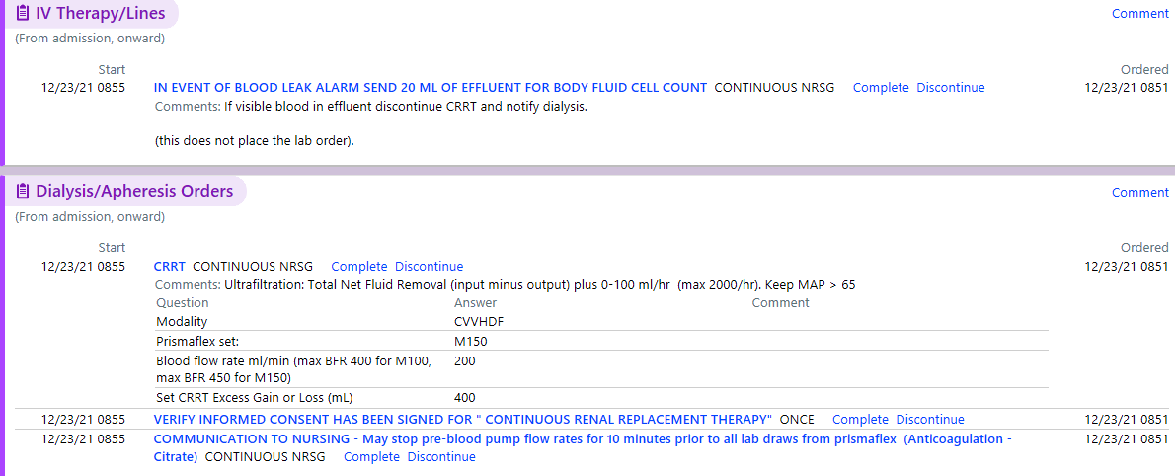



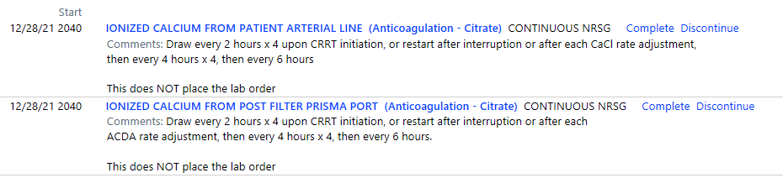

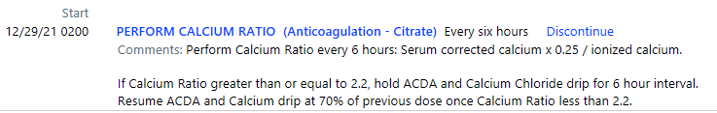



**CRRT Anticoagulation**

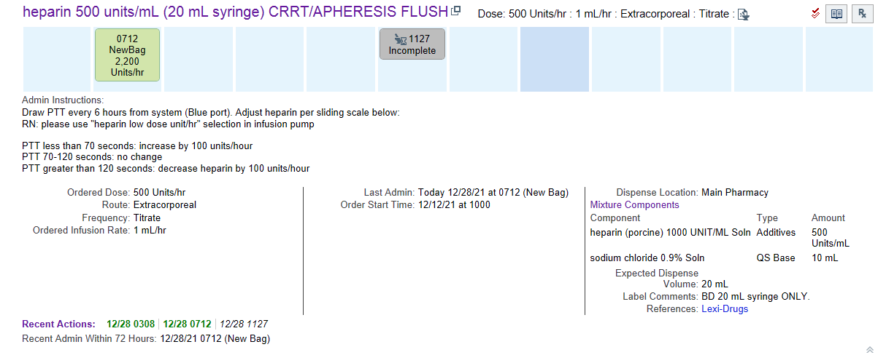

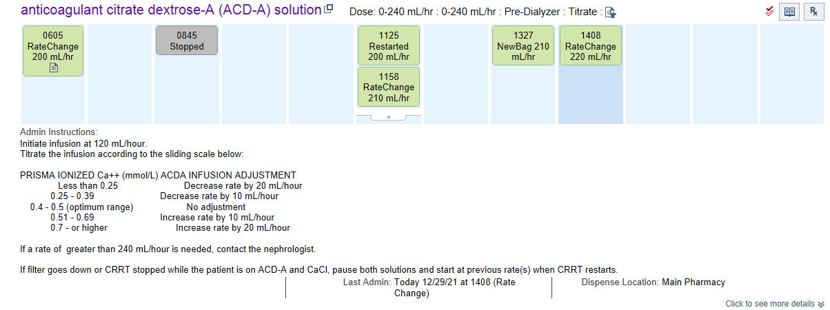

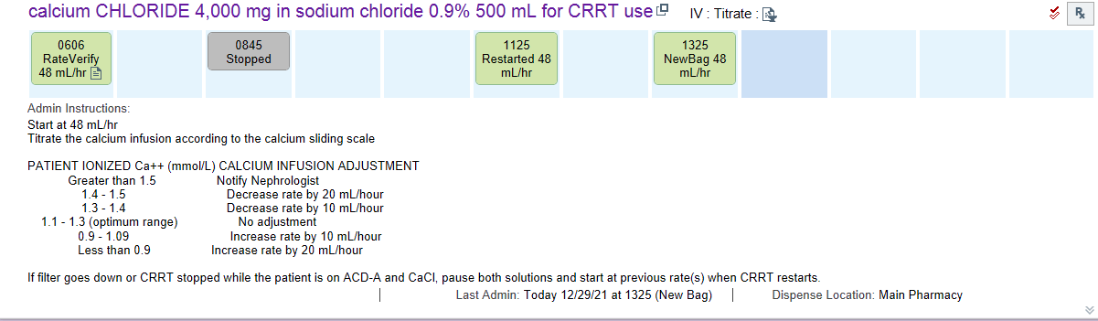

**CRRT Documentation**

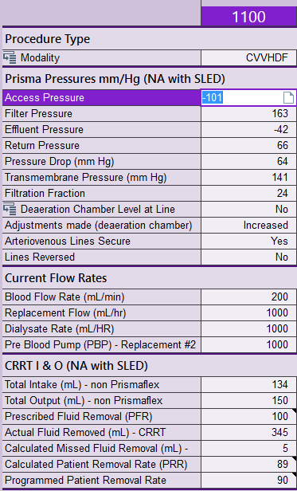

**Filtration Fraction:** UF rate / BFR, higher FF can lead to increased filter clotting (FF>25%)

**CRRT Documentation**

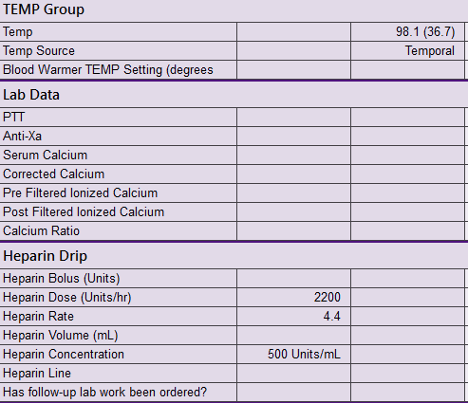

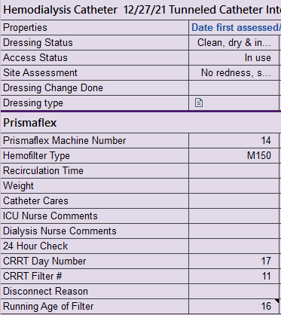

Running Age of Filter: Initial setup is hour 0.

Ex/ CRRT setup at 2358 is hour 0, 0000 is hour 2.

CRRT Day Number: Initial setup is day 1.

Ex/ CRRT setup at 2358 is day 1, 0000 is day 2.

**MAR Electrolyte Replacements**

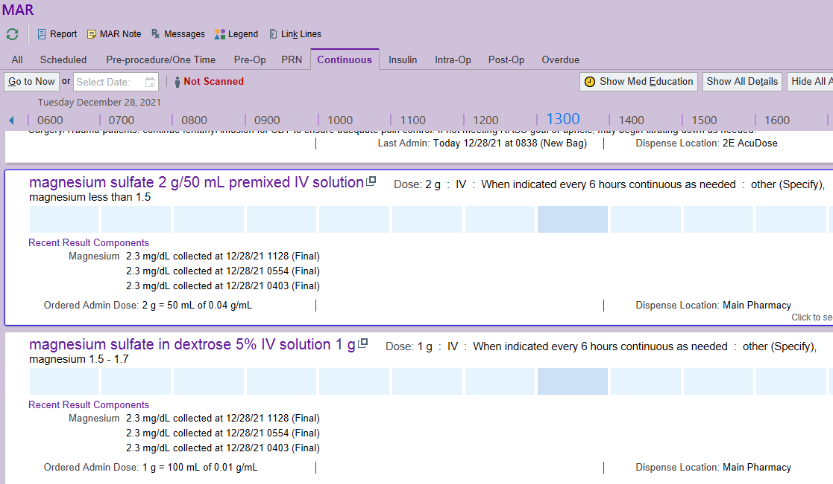

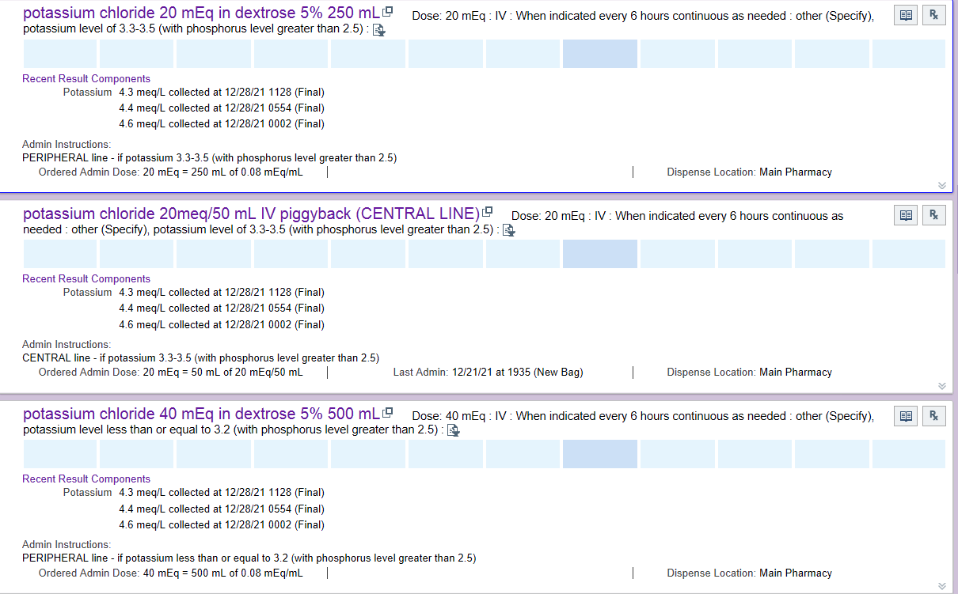

**MAR Electrolyte Replacements**

